

User Documentation

SIP PHONE APPLICATION

Grzegorz Żak
Patryk Szelągowski
Krzysztof Krzyżanowski
Tomasz Krajewski

Table of contents:

1. General Information 2
1.1. Short project’s description. 2
1.2. Sip Account Registration 2
2. Application 4
2.1. Installation 4
2.2. Configuration 5
2.3. First Call 4

General Information

Short project’s description.
SIPphone is a pure SIP app for Android.

Sip Account Registration
User needs to register for a sip account in the SIP server provider. The registration is essential to start using this app. It can be done through f.e LinePhone, Free SIP service on the website:
https://www.linphone.org/free-sip-service.html?page=free-sip-service.html
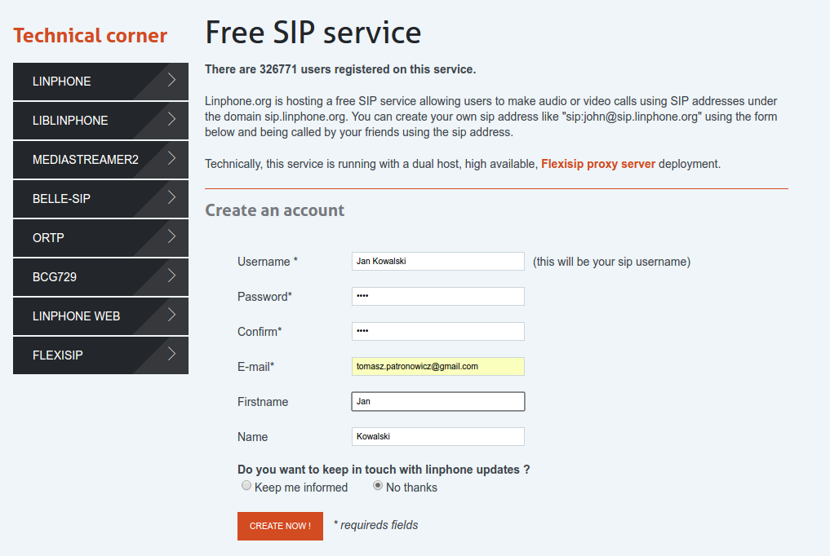
Image 1 User registration for a free SIP account

User needs to give the basic data as username, password, valid email address and first and last name (image 1). After registration and email confirmation SIP account is ready to use. The user gets a login data provided as an email message (image 2).

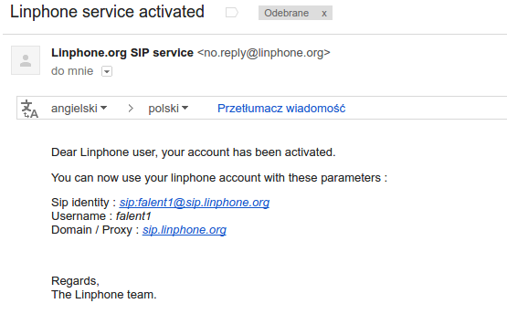
Image 2 User can find login data in the email message after email confirmation

Application

Installation
This app is installed as a standard Android application. It gets access to making/receiving SIP calls, recording audio, controlling phone vibration and changing audio settings (image 3 ).
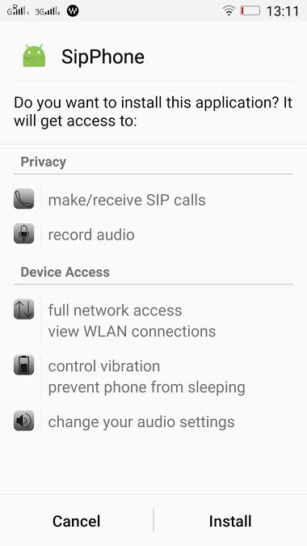
Image 3 SipPhone Installation
After Installation user can find this app in the standard android menu

Configuration
After installation user needs to set up this application. It can be done by clicking ”Edit your SIP info” in the main view (image 4).

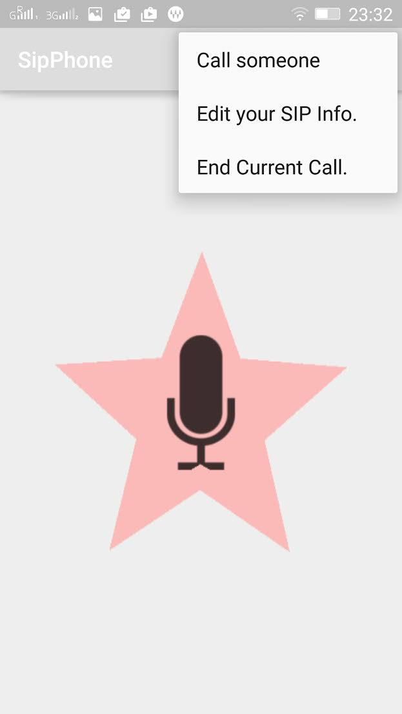
Image 4 Main menu
After that user needs to fill out SIP username, Domain for SIP Account, Outbound Proxy Address and password (image 5). All required data were sent after SIP account registration.

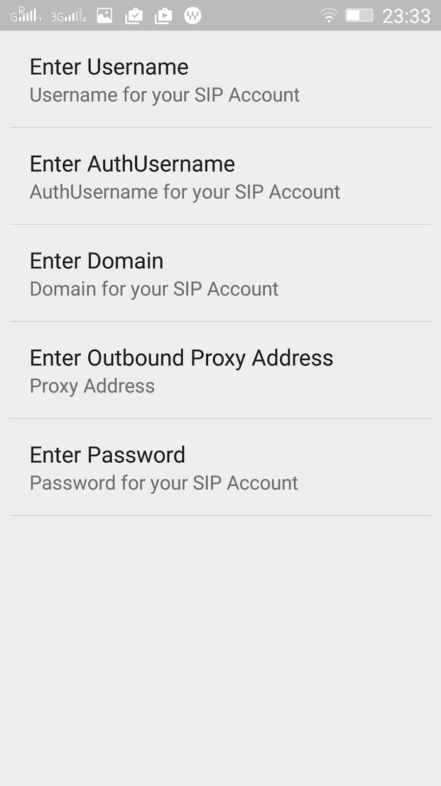
Image 5 User account settings
If user filled out this form with right data the application is ready to use (image 6).
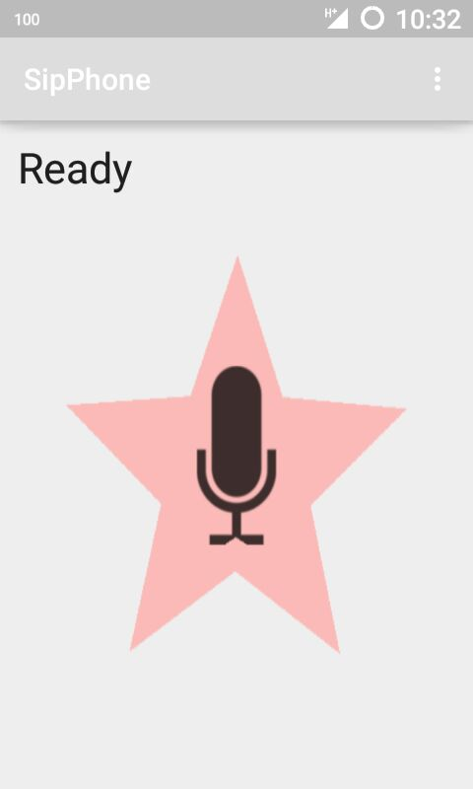
Image 6 App is ready to use

It can happen that data are wrong or there is no connection to the server. After that user gets an information (image 7).
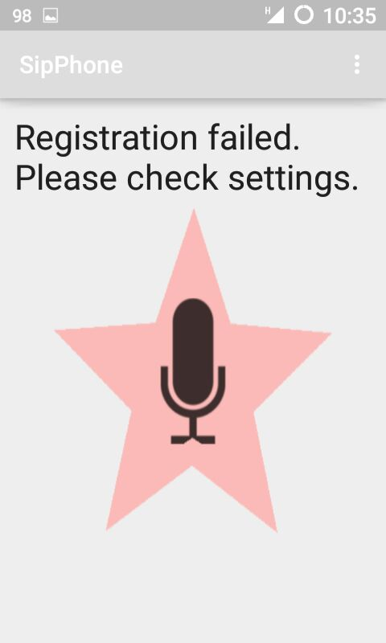
Image 7 Registaration failed

First Call

If user gets on the screen a word “Ready” in the main app view it can be made a first call. In the menu user needs to choose “Call someone” option. The user contact is in a format of username@domain (image 8).

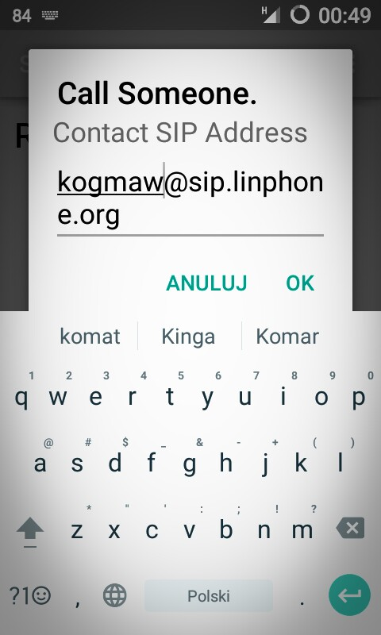
Image 8 Adding a user for a call

If user needs to say something it is required to push a red star button on the main view. The SipPhone works like old Walkie-talkie concept (image 9).

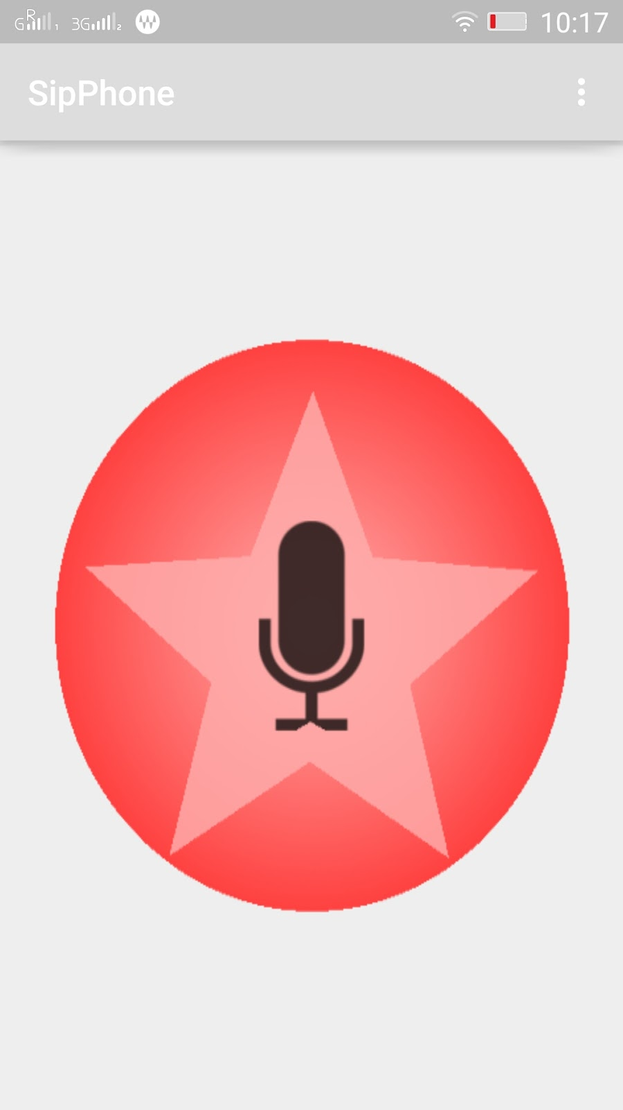
Image 9 If user needs to say something it is required to push a red star button

